“Rikki-Tikki-Tavi”
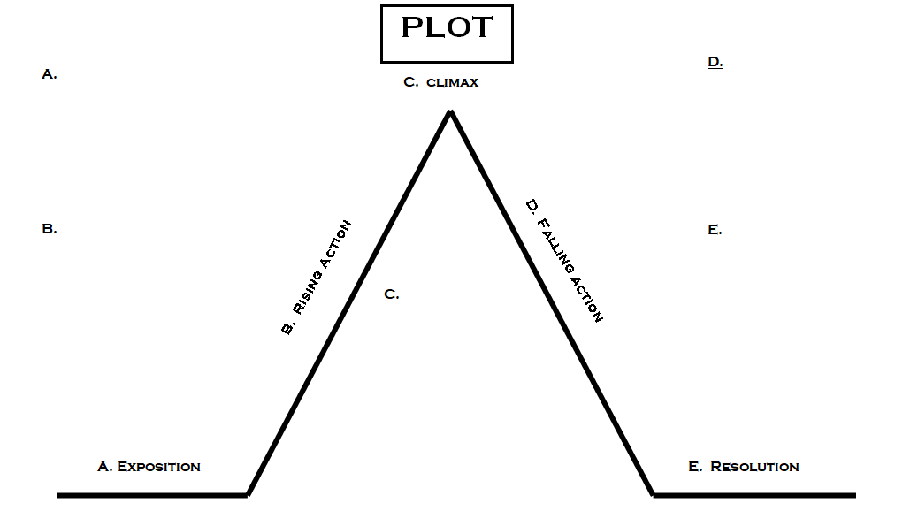
By Rudyard Kipling
Characterization

1. Identify THREE personality traits in Rikki. Use details from the story to support each trait.

Trait #1 -

Supporting details –

Trait #2 -

Supporting details –

Trait #3 -

Supporting details –

2. Identify TWO personality trait in Nagaina. Use details from the story to support the trait.

Trait #1 -

Supporting details –

Trait #2 -

Supporting details –

3. Identify ONE personality trait in Nag. Use details from the story to support the trait.

Trait #1 -

Supporting details –

Conflict

1. What is the main conflict in this story?

2. What type of conflict is it?

Setting

1. What is the setting of this short story?

2. What details provide information about the setting?

Theme

1. What lesson or message about life does the reader gain from this short story? (Consider what the characters learned over the course of the story.)

2. What details from the story help you to identify this theme?

