Name_______________________________ Date_______________________________

“Happy Poem”
Directions: Read the following poem and decide what tone and mood this poem contains.
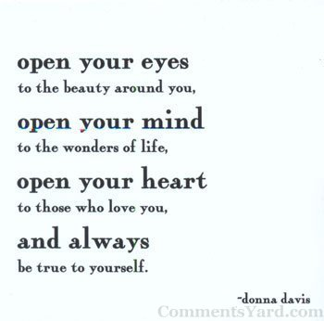
This poem’s tone is_____________________________________________________________________
This poem’s mood is____________________________________________________________________
The key words that prove my answers are: __________________________________________________
_____________________________________________________________________________________

Now, change those key words in the poem to create an entirely different mood or tone! Be creative!
_____________________________________________________________________
_____________________________________________________________________
_____________________________________________________________________
_____________________________________________________________________
_____________________________________________________________________
_____________________________________________________________________
_____________________________________________________________________

