Name: _____________
“A Christmas Carol”
By Charles Dickens

MY ROLE(S) IS/ARE: ___________________________
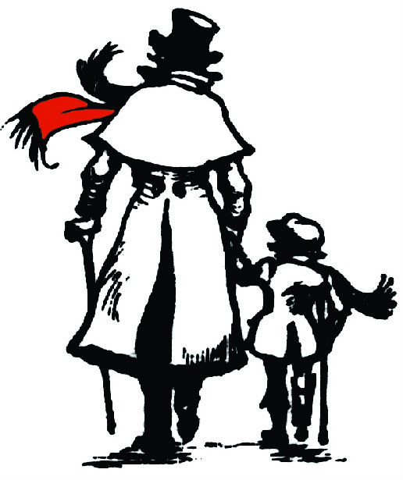

CHARACTERIZATION
Identify a personality trait in Scrooge’s character at the beginning of the play.

Identify a personality trait in Scrooge’s character after he meets the Spirit of Christmas Past.

Identify a personality trait in Scrooge’s character after he meets the Spirit of Christmas Present.

Identify a personality trait in Scrooge’s character after he meets the Spirit of Christmas Yet to Come.

Is Scrooge a dynamic or a flat character? Provide specific evidence to support your answer.

CONFLICT

Identify two conflicts in the story. What type of conflict are they?

PLOT

What do you think is the CLIMAX of “A Christmas Carol”? Why do you think this is so?

SETTING

What is the setting of this story?

What details provide information about the setting?(consider the stage directions,
dialogue, etc.)

SYMBOLISM

The chains worn by Marley in Scene 2 are a symbol. Explain what they symbolize.

THEME

The THEME of a story is the message about life, or lesson that the reader takes away after reading. What do you think the theme of “A Christmas Carol” is? What evidence from the story contributes to your understanding of the theme?

